Task 7: Interactive Web Form with Events & Functions
AIM:
To design and develop an interactive web-based feedback form using HTML, CSS, and JavaScript that performs real-time input validation, enhances user interaction through event handling (keypress, mouse hover, and double-click), and ensures reusable validation using JavaScript functions.
ALGORITHM:
- Start the program
- Create the HTML structure
- Apply CSS styling
- Implement keypress event validation
  - On each key press (onkeyup):
    - Call validation functions
- Display validation messages
- Create reusable JavaScript functions
  - validateName()
  - validateEmail()
  - validateFeedback()
- Handle mouse hover event
- Implement double-click submit
  - Use ondblclick event on submit button
  - Call submitForm() function
- Validate all inputs before submission
- Display success message
- End the program
PROGRAM:
<!DOCTYPE html>
<html>
<head>
<title>Feedback Form</title>
<style>
input, textarea {
display: block;
margin: 10px;
padding: 8px;
}
input:hover, textarea:hover {
border: 2px solid blue; /* Hover effect */
}
.error {
color: red;
font-size: 12px;
}
</style>
</head>
<body>
<h3>Feedback Form</h3>
<form>
<input type="text" id="name" placeholder="Name" onkeyup="validateName()">
<span id="nErr" class="error"></span>

<input type="email" id="email" placeholder="Email" onkeyup="validateEmail()">
<span id="eErr" class="error"></span>

<textarea id="msg" placeholder="Feedback" onkeyup="validateMsg()"></textarea>
<span id="mErr" class="error"></span>

<button type="button" ondblclick="submitForm()">Submit</button>
</form>
<script>
function validateName() {
let n = document.getElementById("name").value;
document.getElementById("nErr").innerHTML =
(n.length < 3) ? "Min 3 chars" : "";
}
function validateEmail() {
let e = document.getElementById("email").value;
let pattern = /^[^ ]+@[^ ]+\.[a-z]{2,3}$/;
document.getElementById("eErr").innerHTML =
(!e.match(pattern)) ? "Invalid email" : "";
}
function validateMsg() {
let m = document.getElementById("msg").value;
document.getElementById("mErr").innerHTML =
(m === "") ? "Required" : "";
}
function submitForm() {
if (
document.getElementById("nErr").innerHTML === "" &&
document.getElementById("eErr").innerHTML === "" &&
document.getElementById("mErr").innerHTML === ""
) {
alert("Feedback Submitted!");
} else {
alert("Fix errors first!");
}
}
</script>
</body>
</html>
OUTPUT:
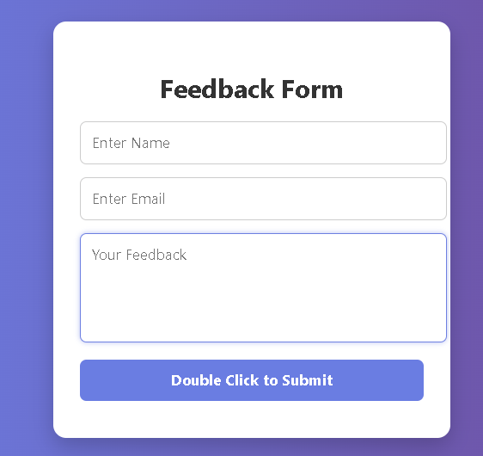
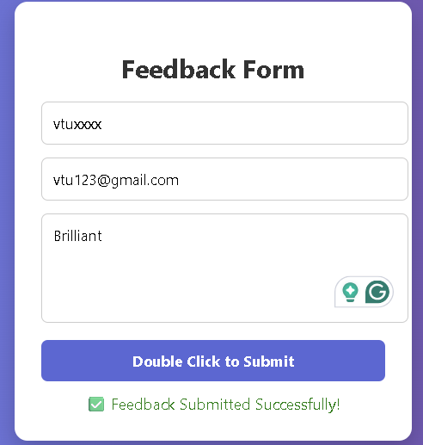

RESULT:
The interactive feedback form was successfully designed and implemented using HTML, CSS, and JavaScript. The application performs real-time validation of user inputs using keypress events, ensuring that incorrect data is immediately identified and corrected.

